**OOP Lab #2**

**Create Multiple References of an Object**

**Multiple References:**

A variable that points to be a reference type to another variable of the same type , both variables end up pointing to the same memory. This means that changing the contents of the object through the first reference results in changes that are also seen by the second reference.

Sample Code

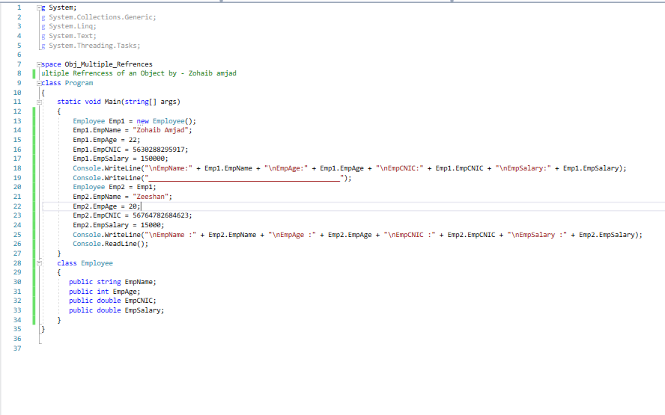

Out put

